1) Buy Avery 18662 clear 1 1/3” x 4 ¼” clear labels from staples or online.
https://www.amazon.com/AVERY-DENNISON-18662-Mailing-Labels-Printers/dp/B007Z7L25I/ref=sr_1_12?keywords=avery+clear+labels+5662&qid=1569000638&sr=8-12
2) Open this document in Microsoft word,
3) Go to mailings tab and then click labels.
4) Open up Label box and scroll to 5662 for the label layout. It must display size 1 1/3” x 4 ¼”
5) Cut and paste numbering below into the label box

16 15 14 13 12 11 10 09 08 07 06 05 04 03 02 01
| | | | | | | | | | | | | | | |

6) Highlight all the above numbers in the label box and right click highlight
Click “Font” and set to “Arial”
Click “Font Style” and set to “Bold”
Click “Size” and set to “8”
Place Avery sheet in printer and print a page of labels.
7) Trim one label to just numbers and lines
8) Peel off label and align #02 of new label with K-factor 50 line
Finished product should look like this.
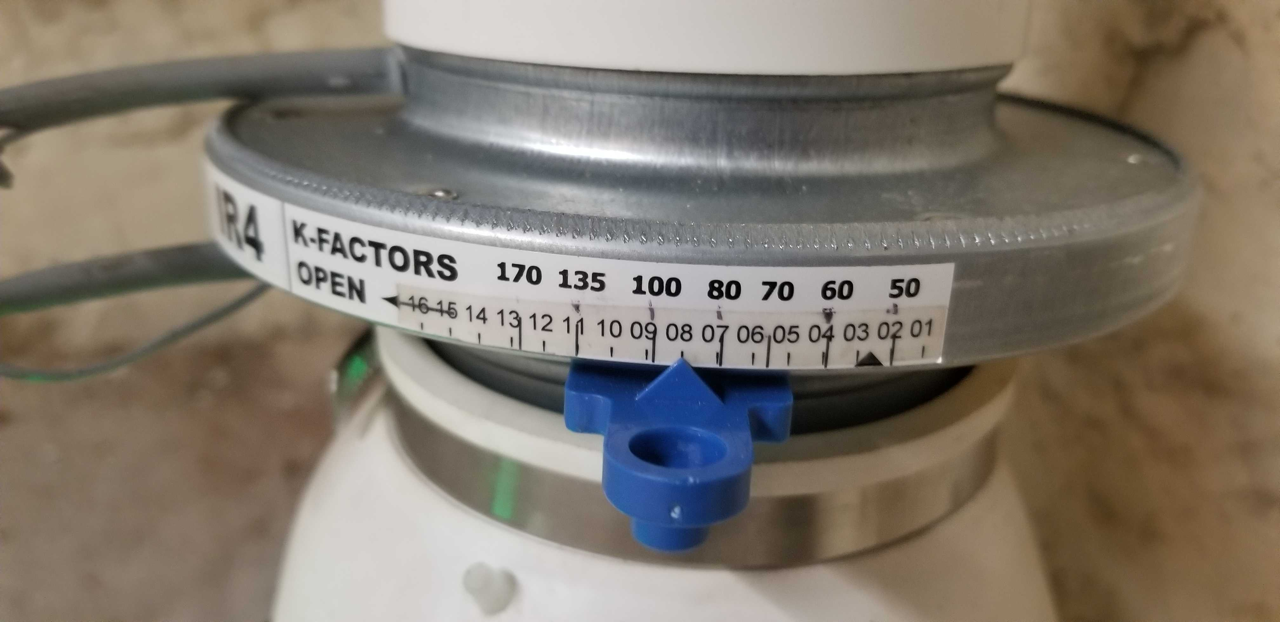

On following pages are the settings for different radon fans and equivalent feet of piping.
Print the following pages and tape the fan settings and Equivalent feet to the body of the PFEDK so they are always available.

Tape these Fan settings on the side of the PFEDK fan

Fan Type | Voltage setting | IR setting 10'-4" | IR setting 110'-4" | IR setting 103'-3"
RN1 | 4.5 | 14.0 | 9.0 | 3.8
RP140 | 4.15 | 13.5 | 9.0 | 3.8
PDS 150 | 6.0 | 13.5 | 9.1 | 3.8
RN2EC-4 | 6.2 | 12.4 | 8.7 | 3.3
Maverick | 6.0 | 12.6 | 8.5 | 3.8
RN2 | 6.4 | 10.0 | 7.2 | 3.0
Fan Type | Voltage setting | IR setting 10'-4" | IR setting 110'-4" | IR setting 103'-3"
GBR45 | 6.1 | 12.8 | 8.8 | 4.0
RP145 | 6.3 | 10.5 | 8.0 | 3.2
RP265 | 6.8 | 14.1 | 9.0 | 3.9
Legend | 7.2 | 15.0 | 9.5 | 4.3
RN3 | 7.4 | 15.2 | 9.5 | 4.3
Fan Type | Voltage setting | IR setting 10'-4" | IR setting 110'-4" | IR setting 103'-3"
Fury II | 8.7 | 12.8 | 9.0 | 4.0
Eagle | 8.8 | 7.1 | 5.3 | 2.7
GP501 | 9.6 | 2.3 | 1.9 | 0.3
Eagle Extreme | 9.5 | 10.4 | 7.8 | 3.8
RN4-4 | 10.1 | open | 10.4 | 4.5
These are the equivalent lengths of piping for each fitting that is used. If you use four sweep 90 degree four inch elbows it adds an additional 4.8 X 4 = 19.2 feet of 4” pipe of resistance. Add up all the piping lengths that the system will use. Then calculate the resistance equivalent in additional feet of pipe for all the elbows that you will use. Add them together to get the total equivalent feet of piping that the fan will have to work against. The SOD has the IR4 damper setting for 10 feet of piping and 110 feet of piping. You can vary the IR4 damper setting by the approximate amount of additional feet more or less than 110 feet your system will have.
Tape this chart on your fan.
Fittings - Pipe Type | Sch 20 | Sch 40 | Sch 20 | Sch 40
at 75 CFM | 3" | 3" | 4" | 4"
90 Sweep | 3.2 | 4.4 | 5.8 | 4.8
90 Hard Turn | 13.0 | n/a | 17.0 | n/a
45 Sweep | n/a | 2.0 | n/a | 2.0
45 Angled | 4.0 | 3.7 | 6.7 | 5.3
90 Sweep offset | 9.0 | 8.5 | 11.3 | 9.8
90 Hard Turn offset | 40.0 | n/a | 52.0 | n/a
45 Sweep offset | n/a | 3.4 | n/a | 4.0
45 Angled offset | 9.8 | 10.1 | 15.9 | 13.2
Reducer 3x2 & 4x3 | 21.8 | 21.8 | 13.5 | 13.5
Pipe Opening | 20.0 | 20.0 | 25.0 | 25.0
Tapered 8" Opening | 14.0 | 14.0 | 17.2 | 17.2

